
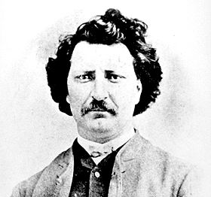
LOUIS AND GABRIEL
#15
MIKE FORD

from the album “Canada Needs You - vol. 1”

MapleMusicRecordings

Vocabulary

- messiah –
- Metis –
- marksman –
- rebellion –
- resistance –
- descend -
- diversity -
- Provisional government -

Do You Know It?

Who were these guys?
- Louis Riel –

- Gabriel Dumont –

- Sir John A. Macdonald –

Did You Catch It?

1. From whom did the Metis descend?
2. What language did they speak?
3. What does, “they lived between two worlds” mean?
4. In what province did Louis live?
7. What happened after the first rebellion?
8. What happened after the second rebellion?

64

Do You Get It?

- What did Louis Riel and the Metis want?

- Who brought Riel back out of exile and why?

- Compare how the Metis view Louis Riel compared to how English Canadians view him.

Activities and Extensions!

- Many words are used to describe Riel: hero, traitor, leader, stubborn, etc. Choose one word to describe Riel, and explain why this word is the best descriptor for him.

- Write an obituary for Riel from BOTH the “victom and “villain” point of view.

- Conduct a mock trail of the Riel case.

- Write a press release on the Resistance and Louis’ return.

- Watch Historica’s – Heritage Minutes, LOUIS RIEL (#23)

Teaching strategy: Play it twice. The first time through, stop it before Louis is hanged. Have the students respond to it. Where do they think he is? Is he apologetic or does he believe he has done what was right? Play it again, this time to the end. How is the scene altered with the dramatic ending?

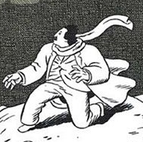
LOUIS RIEL now has his own “Comic Strip Biography”, that was written by Chester Brown. Do you think that this comic makes Riel look like a villain or victim? The picture to the right is from the cover of the comic. What elements of this picture make Louis Riel look like either a hero or a villain?



Teacher’s Guide

BACKGROUND INFO

Louis Riel was of Metis descent. He was a bright young man, but any attempts at formal education failed. He came to believe that he was destined to lead the Metis people and fought for their equal rights in Manitoba. After the first rebellion in 1875, he went into exile, during which he spent time in several insane asylums. Upon returning to Canada, he headed up the Rebellion of 1885,and his friendship with Gabriel Dumont, military head of the Metis, flourished. Riel was imprisoned for treason, tried, found guilty and hanged on November 16, 1885.



ARTIST INFO:

Mike Ford is a Juno-nominated artist whose concerts and recordings are garnering critical and popular acclaim coast-to-coast. Known to many as 1/4 of the eccentrically successful folk-pop-vaudeville band Moxy Früvous, Mike has embarked on a whole new career phase with his rollicking Canada In Song project. Source: www.mikeford.ca

ANSWER KEY

- French voyageurs and First Nations peoples
- French
- neither English nor French
- Manitoba
- personal friend of Louis, a Metis from Manitoba
- Prime Minister of Canada
- Riel left Canada to live in the U.S.
- Riel was imprisoned, tried and hanged

ADDITIONAL RESOURCES

CBC News in Review April 1992- Louis Riel: Changing Perceptions

From SALRC:

VA4310 The Great Possibility: Louis Riel and the Metis Resistance
VA5955 Manitoba:Red River Rebellion (part 1) Saskatchewan: The Northwest Rebellion
VA7174 The Re-trial of Louis Riel (part 1)
VA7175 The Re-trial of Louis Riel (part 2)

